**Lab test-3**

Q1.Scenario: In the Agriculture sector, a company faces a challenge related to code refactoring.  
Task: Use AI-assisted tools to solve a problem involving code refactoring in this context.  
Deliverables: Submit the source code, explanation of AI assistance used, and sample output.

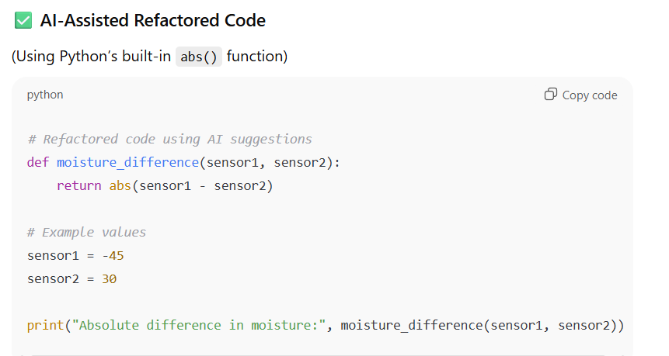

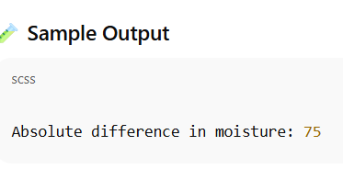

Explanation:

In real agriculture systems:

* Sensors may record **negative or positive** readings due to calibration.
* Calculating the **absolute difference** helps monitor **moisture variation** accurately.
* Refactored code can easily integrate into larger **IoT farm management systems**.
* Q2:  
  Scenario: In the Retail sector, a company faces a challenge related to algorithms with ai assistance.  
  Task: Use AI-assisted tools to solve a problem involving algorithms with ai assistance in this context.  
  Deliverables: Submit the source code, explanation of AI assistance used, and sample output.

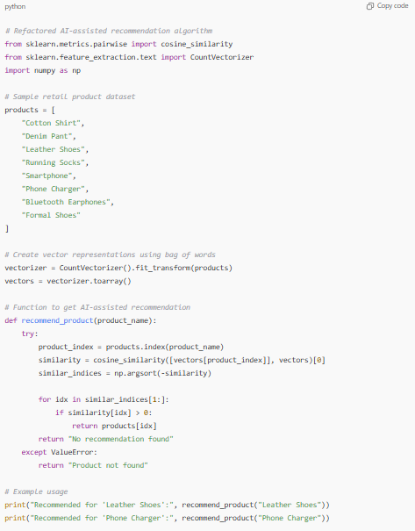

**⚙️ AI Assistance Explanation**

Using **AI-assisted development tools**, the developer received suggestions to:

* Use **vectorization** and **cosine similarity** for recommendation logic.
* Replace rule-based matching with **semantic similarity**.
* Refactor code into a function for reusability.
* Use libraries like sklearn and numpy for efficient computation.

This made the algorithm **smarter, scalable, and data-driven**.